Assignment No. 6 Contents for Theory:

1. Concepts used in Naïve Bayes classifier
2. Naive Bayes Example
3. Confusion Matrix Evaluation Metrics

import pandas as pd import numpy as np

import matplotlib.pyplot as plt

from sklearn.model_selection import train_test_split from sklearn.naive_bayes import GaussianNB

from sklearn.metrics import accuracy_score, precision_score, recall_score, confusion_matrix

url = 'C:/Users/Ashwini/Desktop/Iris.csv' df = pd.read_csv(url)

print("First 5 rows of the dataset:") print(df.head())

|  |  |  |  |  |  |
| --- | --- | --- | --- | --- | --- |
| First 5 rows of the dataset:  Id SepalLengthCm SepalWidthCm PetalLengthCm PetalWidthCm Species | | | | | |
| 0 1 | 5.1 | 3.5 | 1.4 | 0.2 | Iris- |
| setosa |  |  |  |  |  |
| 1 2 | 4.9 | 3.0 | 1.4 | 0.2 | Iris- |
| setosa |  |  |  |  |  |
| 2 3 | 4.7 | 3.2 | 1.3 | 0.2 | Iris- |
| setosa |  |  |  |  |  |
| 3 4 | 4.6 | 3.1 | 1.5 | 0.2 | Iris- |
| setosa |  |  |  |  |  |
| 4 5 | 5.0 | 3.6 | 1.4 | 0.2 | Iris- |
| setosa |  |  |  |  |  |

print("\n Checking for null values:") print(df.isnull().sum())

Checking for null values:

|  |  |
| --- | --- |
| Id | 0 |
| SepalLengthCm | 0 |
| SepalWidthCm | 0 |
| PetalLengthCm | 0 |
| PetalWidthCm | 0 |
| Species | 0 |
| dtype: int64 |  |

df['Species'] = df['Species'].astype('category').cat.codes

X = df.drop(columns=['Species']) Y = df['Species']

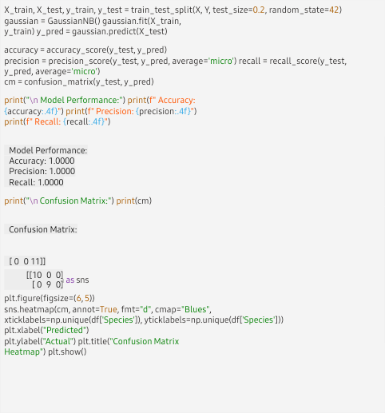

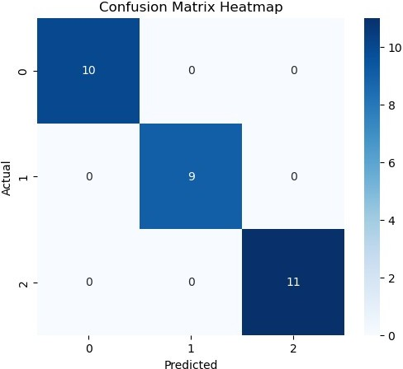

Name:Prathmesh Nakhate 13241